# Project 1 Overall description:

In this project, we get a bunch of data form SNS website. There are two types of files we need to deal with: edges files and circles files. The edge represents user. Once a user got a connection with another user, he gets an edge. The edges files record all edges in each user. The circle represents social network. In each circle file, we can find how many friends and connections he has. What we need to do is combine these two kind of files, and create a graph and analysis it.

# 1.Merge and load the data.

We install sna, igraph and tools packages and read all file index from the dataset and write two functions to read the file from edges and circles file separately.

Before merging these files, we already cleared the circle files with no data inside.



# 2.Connect all edges with circles.

# We use rbind function to combine edges and circles files with same index copprespondly.



# 3.Create a new graph.

Using total edges to create a new graph, and simplify it. Then, we add weights to edges and circles and get a subgraph.



### Here is the plot of total_graph.

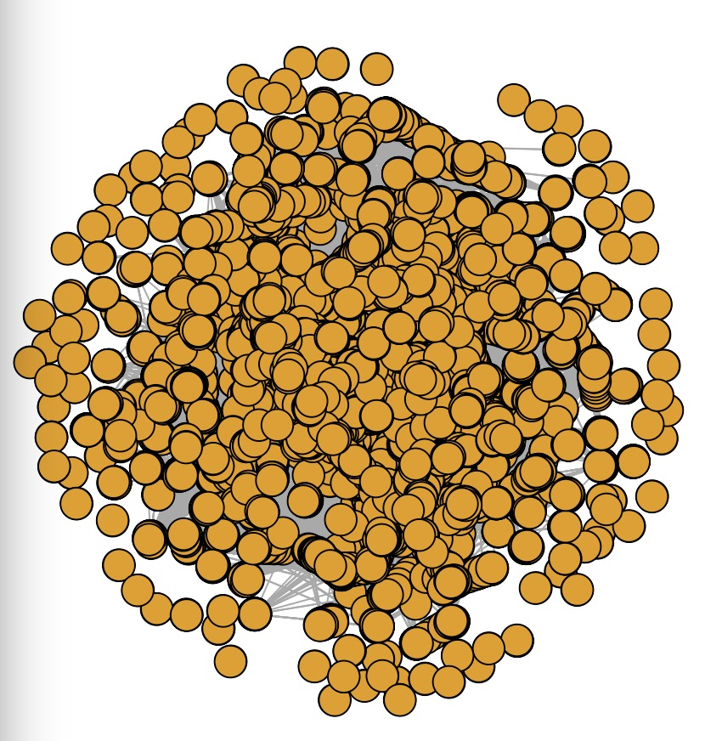

# 4.Functions experiments in the lecture notes:

### (1) V(g) and V(sg).

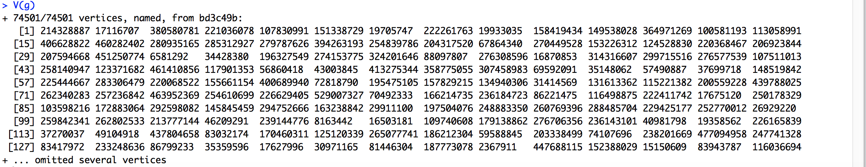

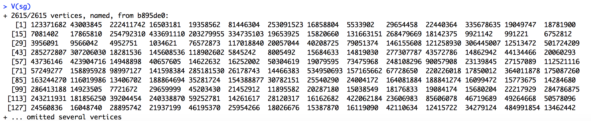

### (2) vertex_attr and gpage_rand

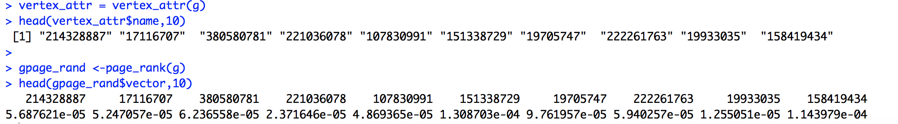

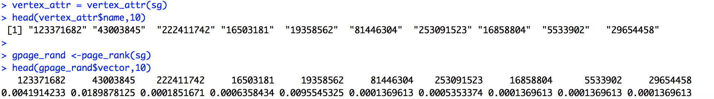

### (3) simplify

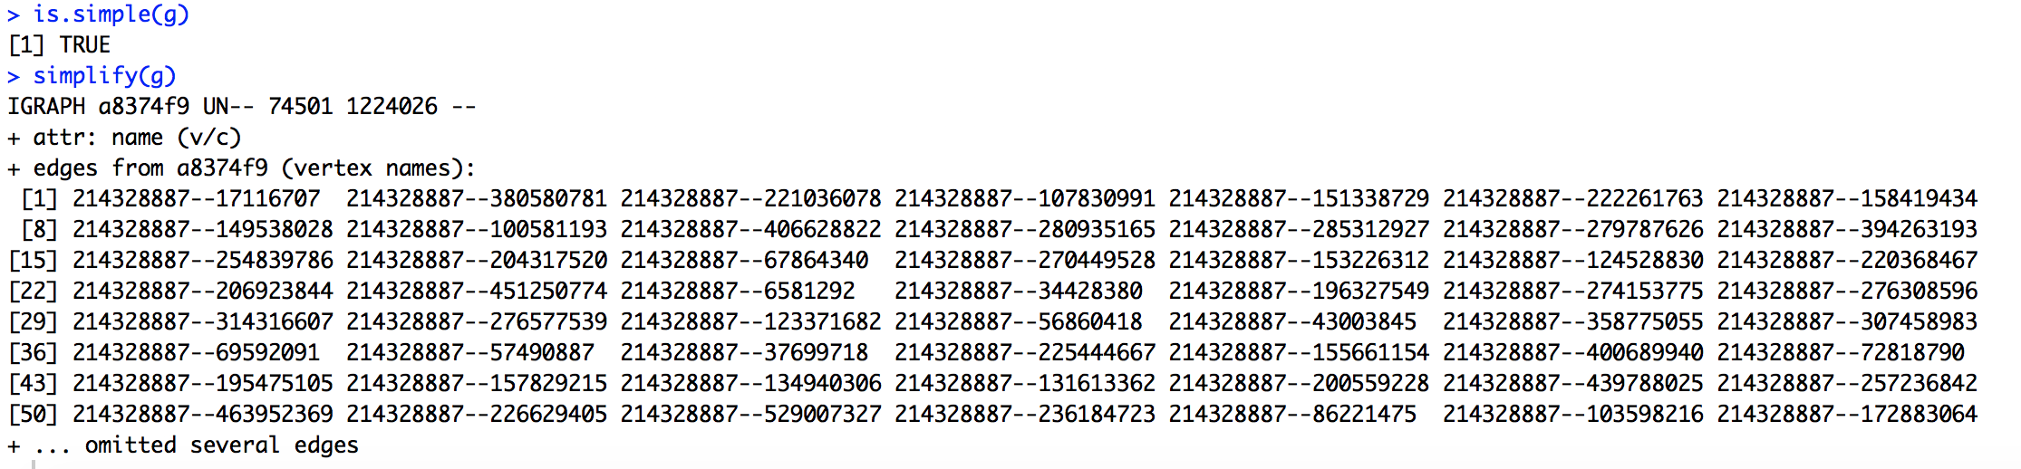

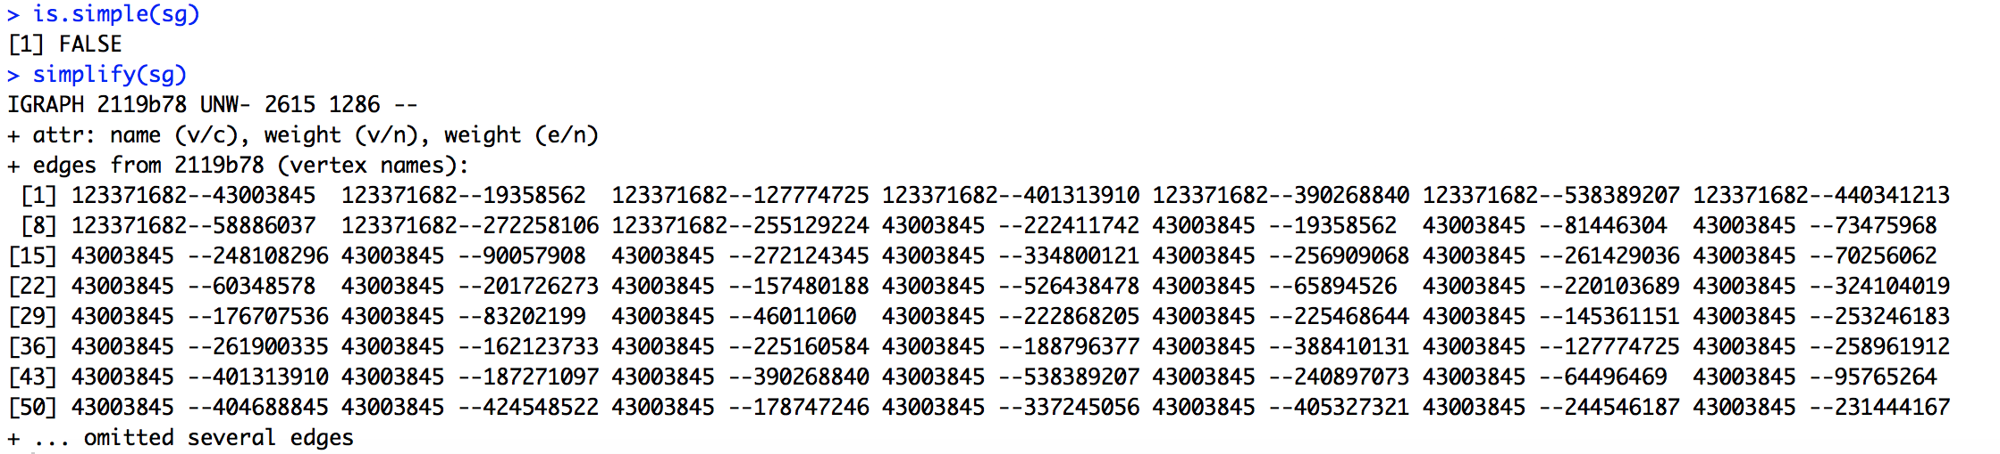

### (4) Arbitrary graph

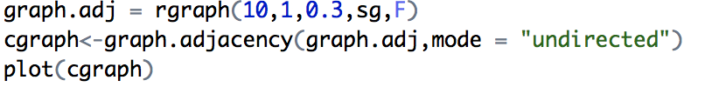

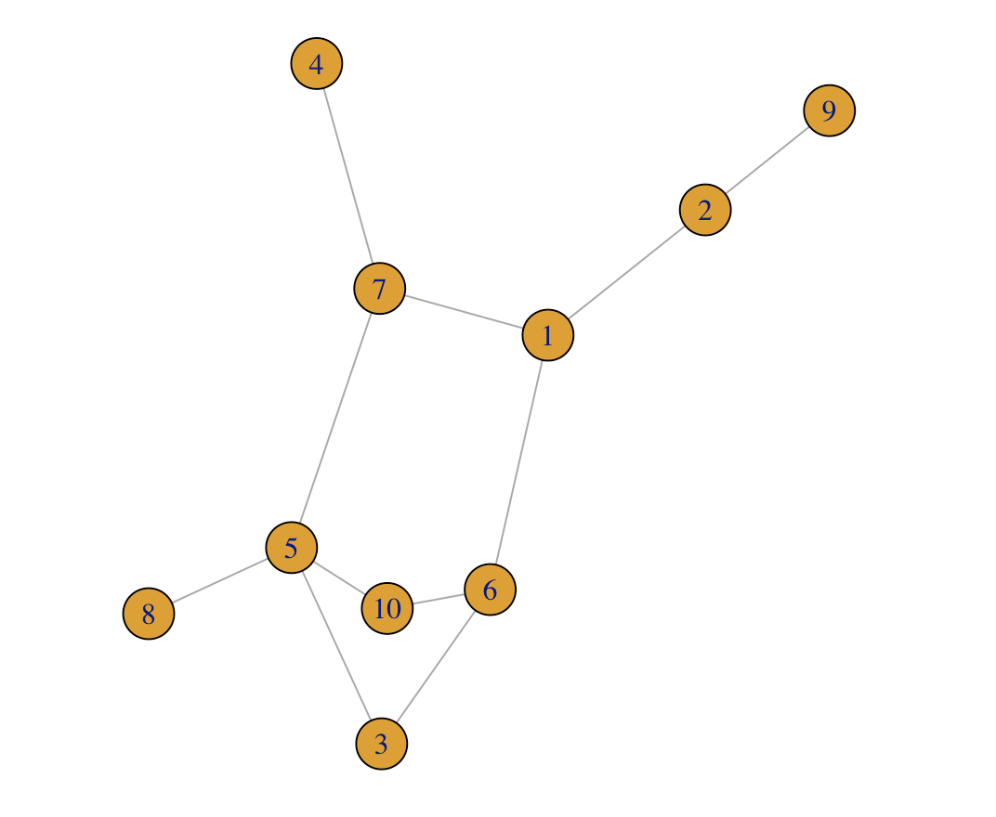

### density:

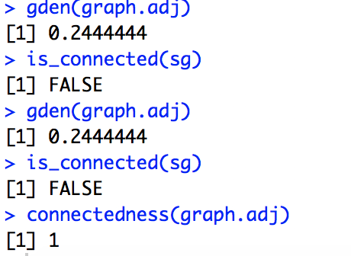

### (5) components

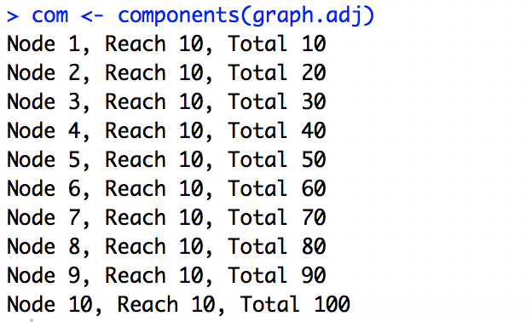

### (6) weight

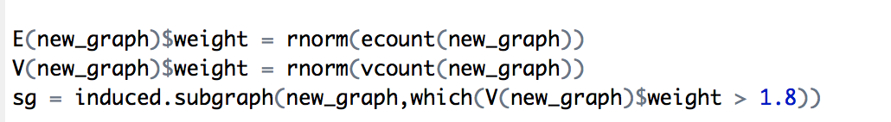



# 5.Functions in igraph

### (1) hist and degree distrabution

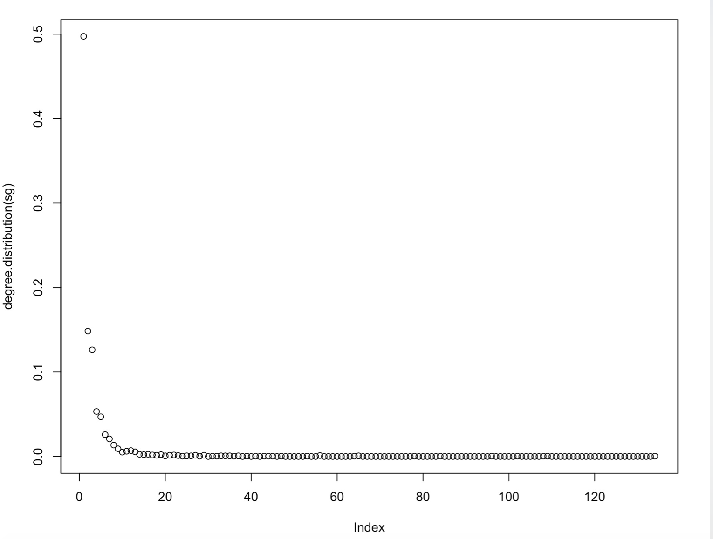

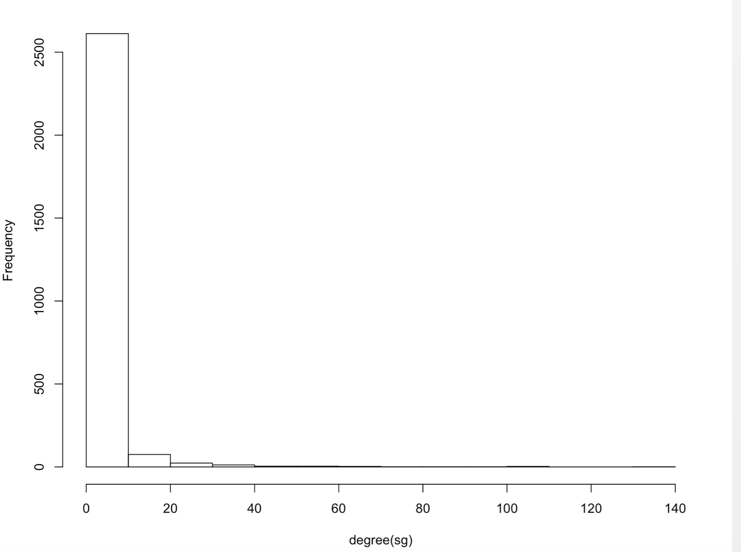

### (2) delete vertices

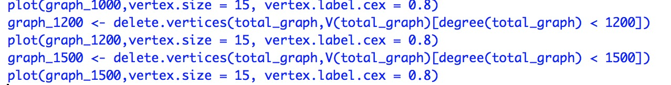

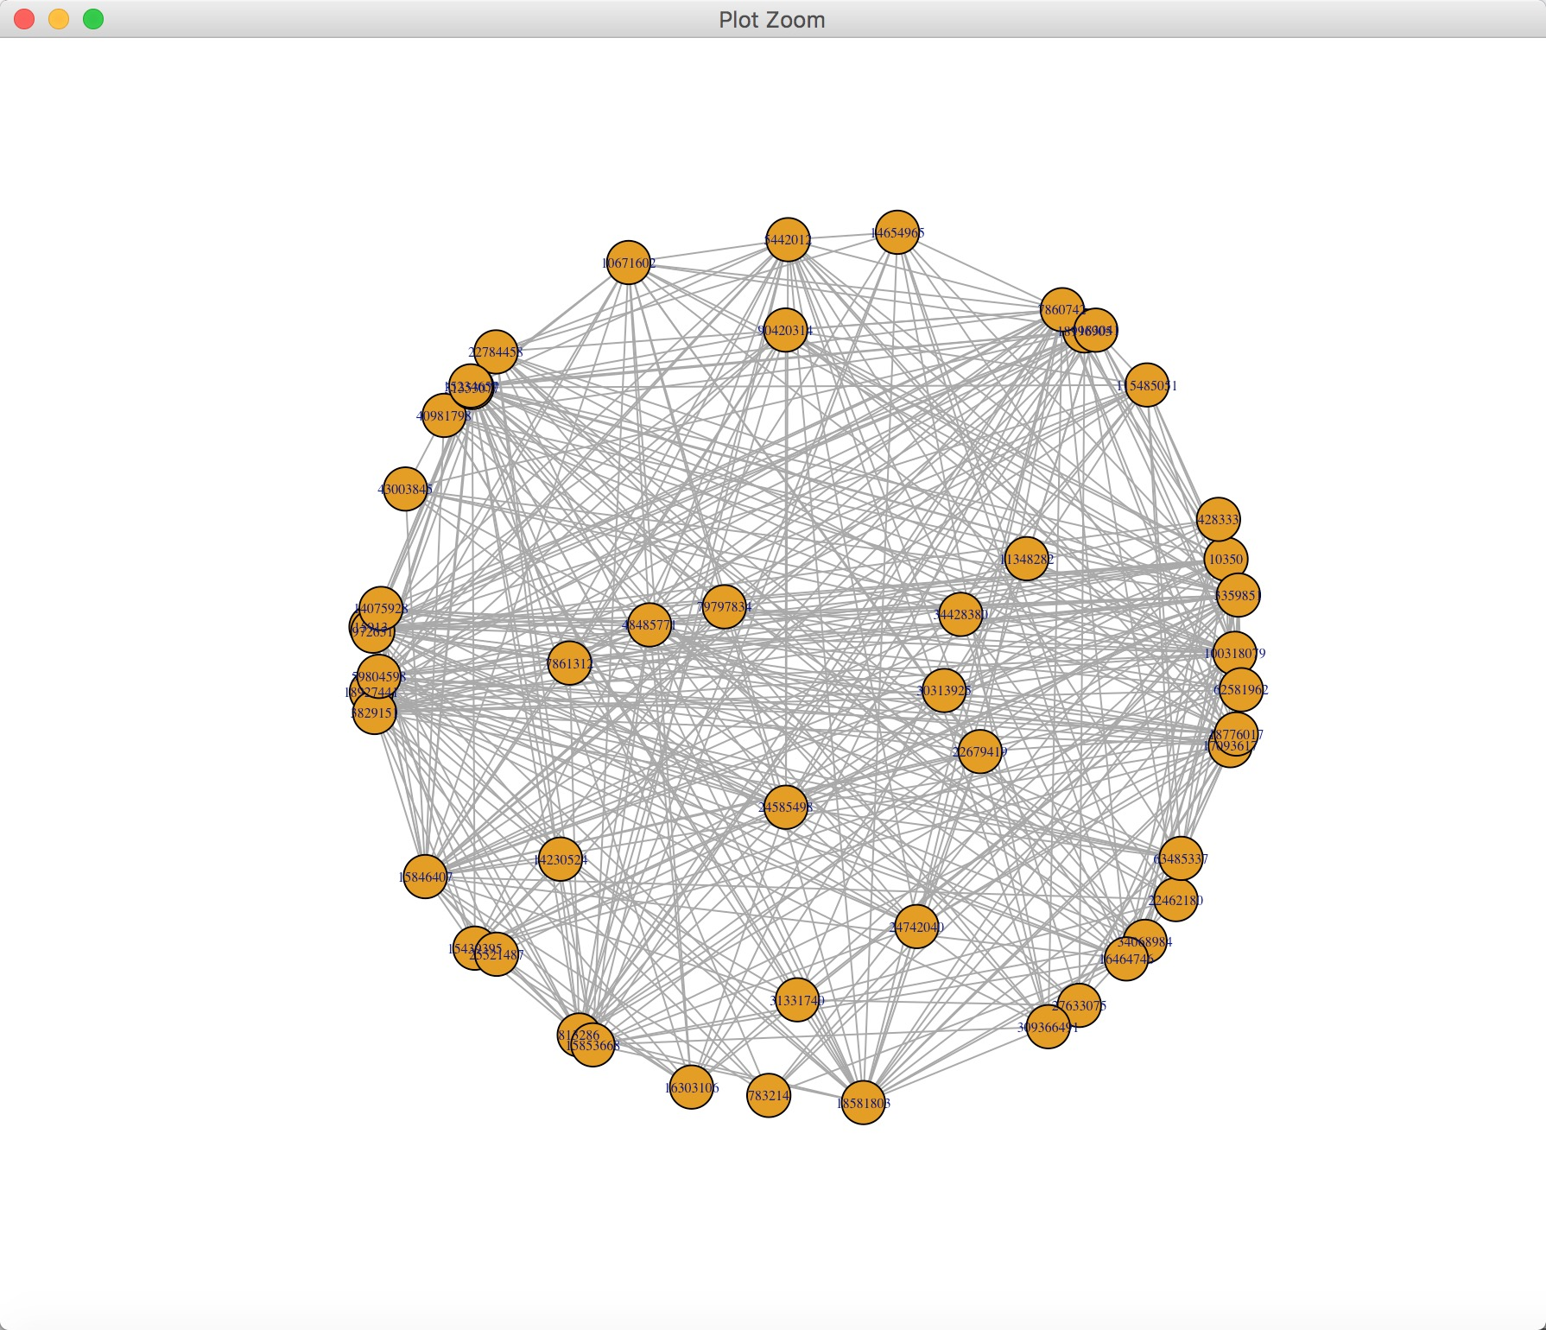

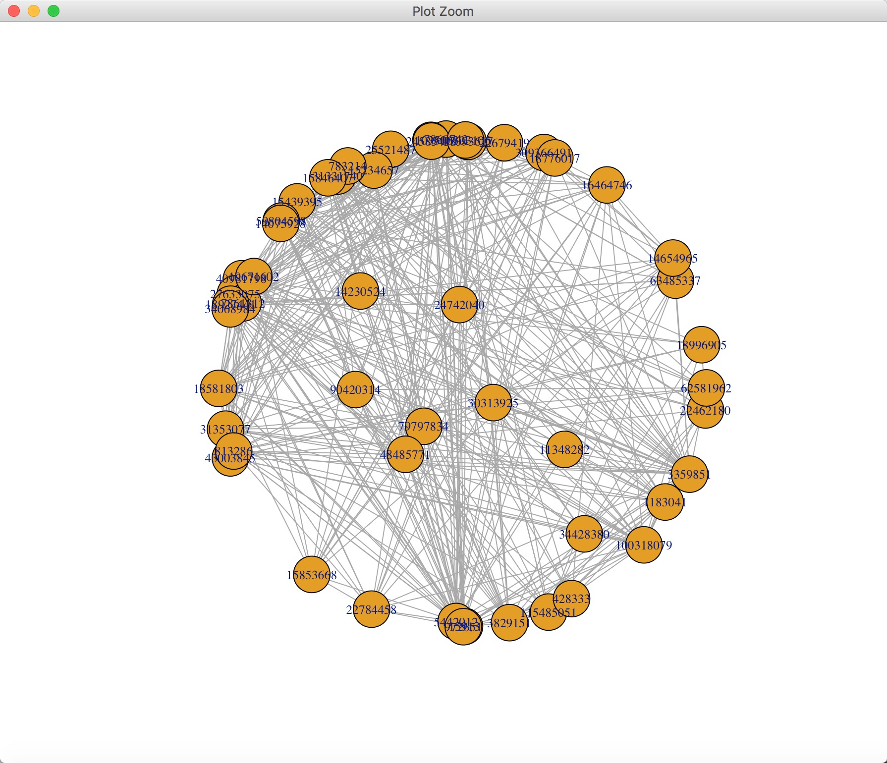

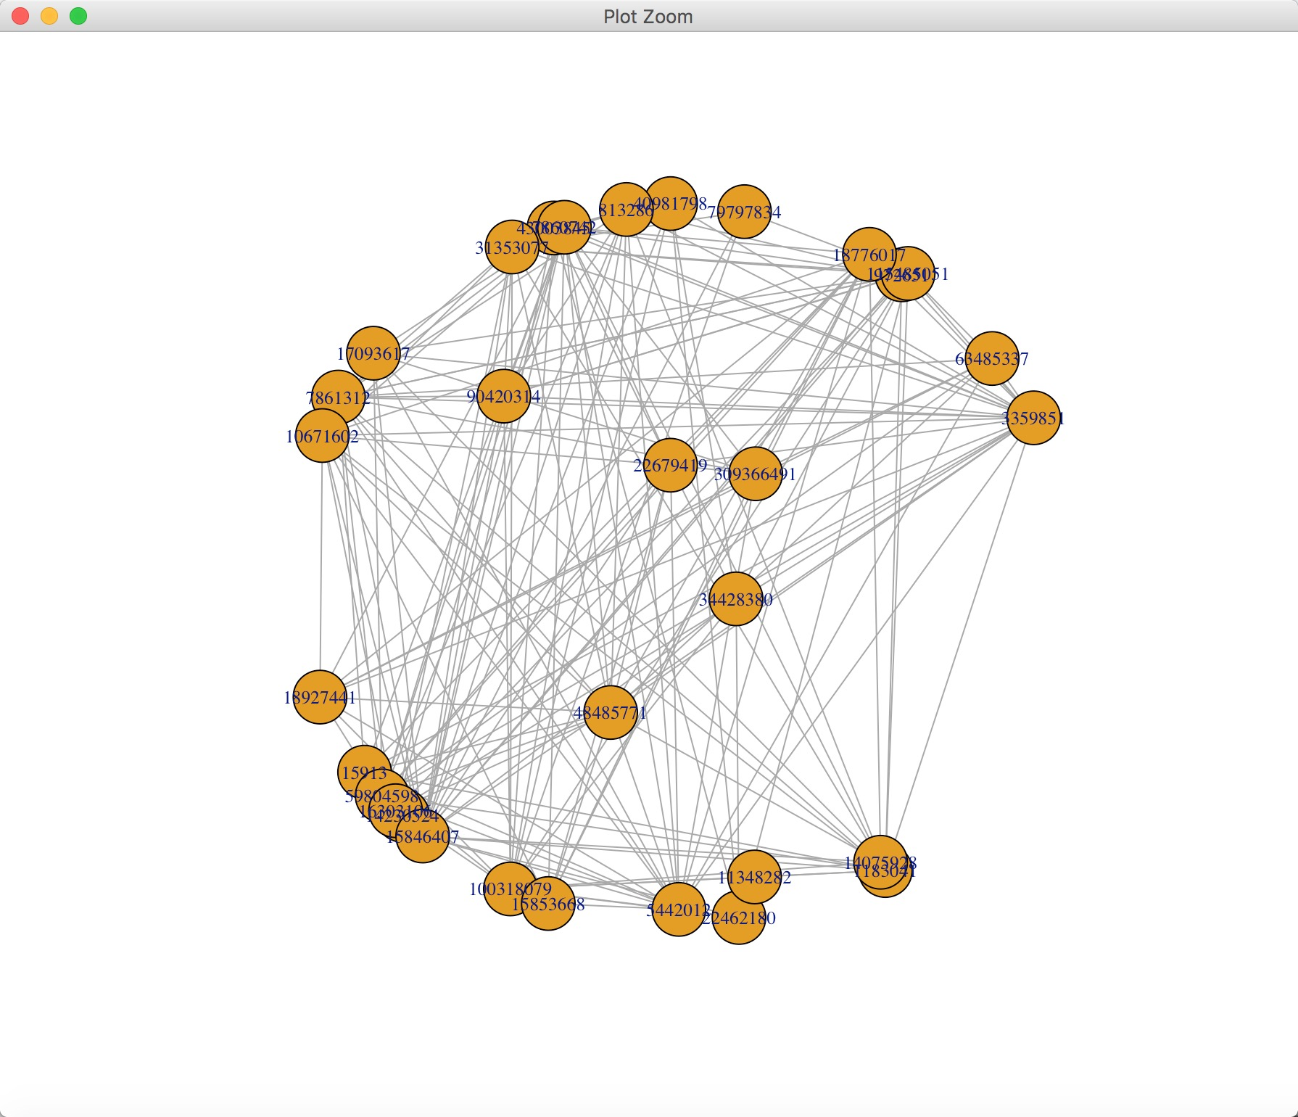

### (3) clique

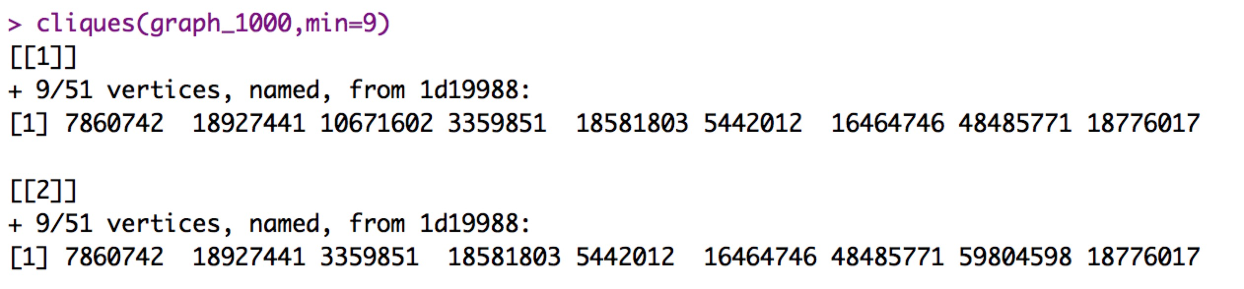

### (4) independence number

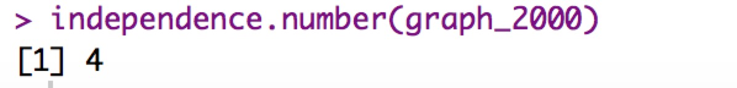

### (5) is_directed, Check whether a graph is directed



### (6) distances

### This function calculates the length of all the shortest paths from or to the vertices in the network. shortest_paths calculates one shortest path (the path itself, and not just its length) from or to the given vertex.



### (7) neighborhood



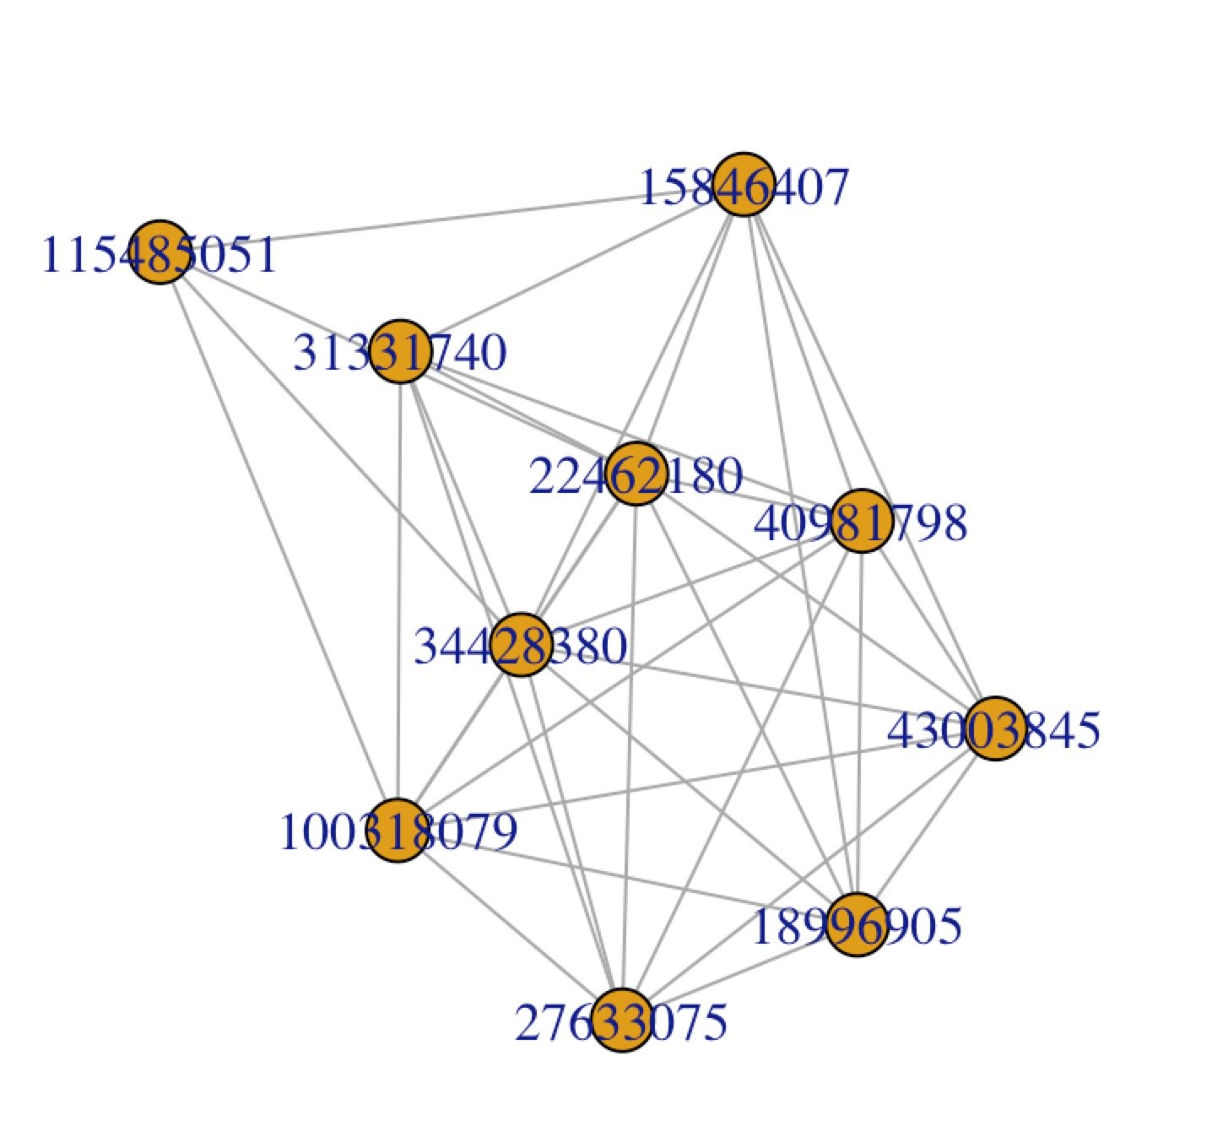

### (8) Maximal independent vertex sets

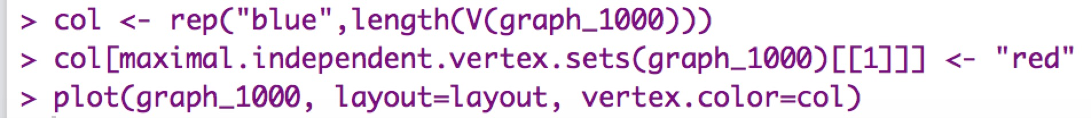

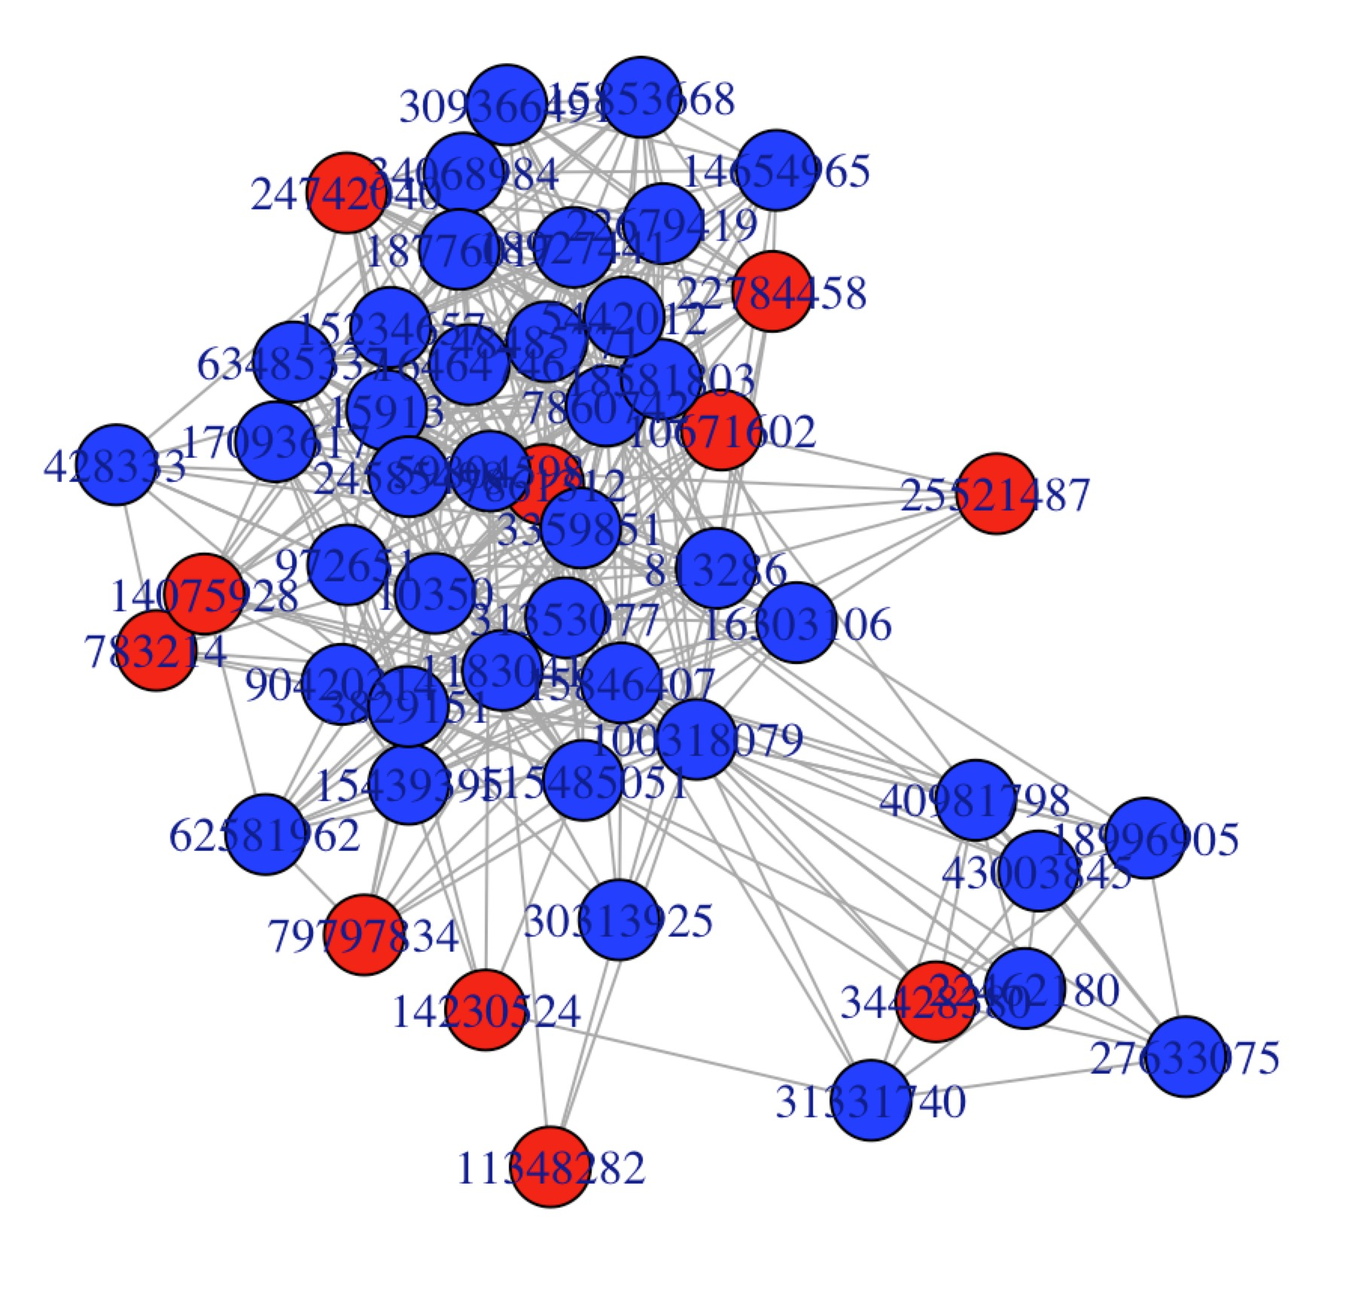

(9) create a random graph and plot the picture





(10) Find connected components





5. **Determine the (a) central person(s) in the graph, (b) longest path, (c) largest clique , (d) ego, and (e) power centrality.**

### (1) central person

In order to find the find the central person, we need to find the node with highest degree, we can delete the verticens constistantly until we find the last one.

As below, we try 1000,2000,3000,3250 vertice delete, till we find the central person 40981798





### (2) longest path

the longest path of a graph means the diameter , so we use dianmeter to find the longest pah in graph_100 ,200,500, 1000

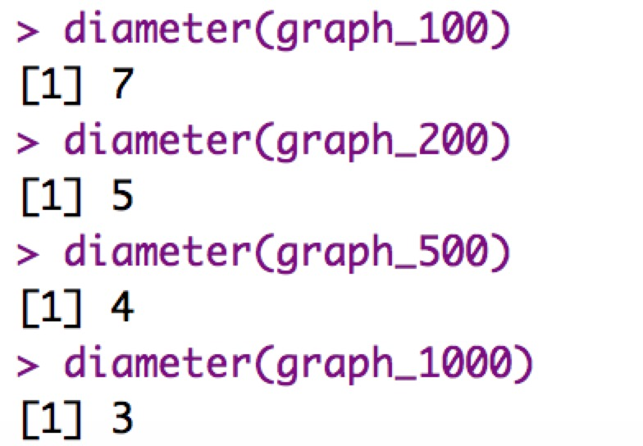

### (3) largest clique

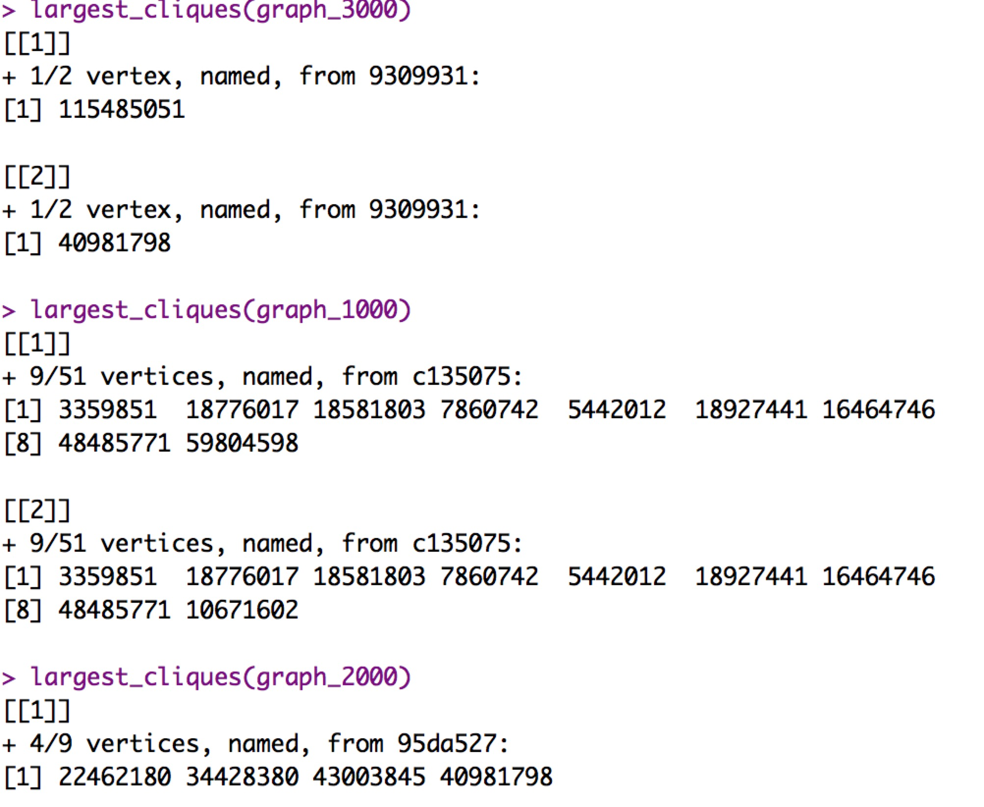

### (4) ego

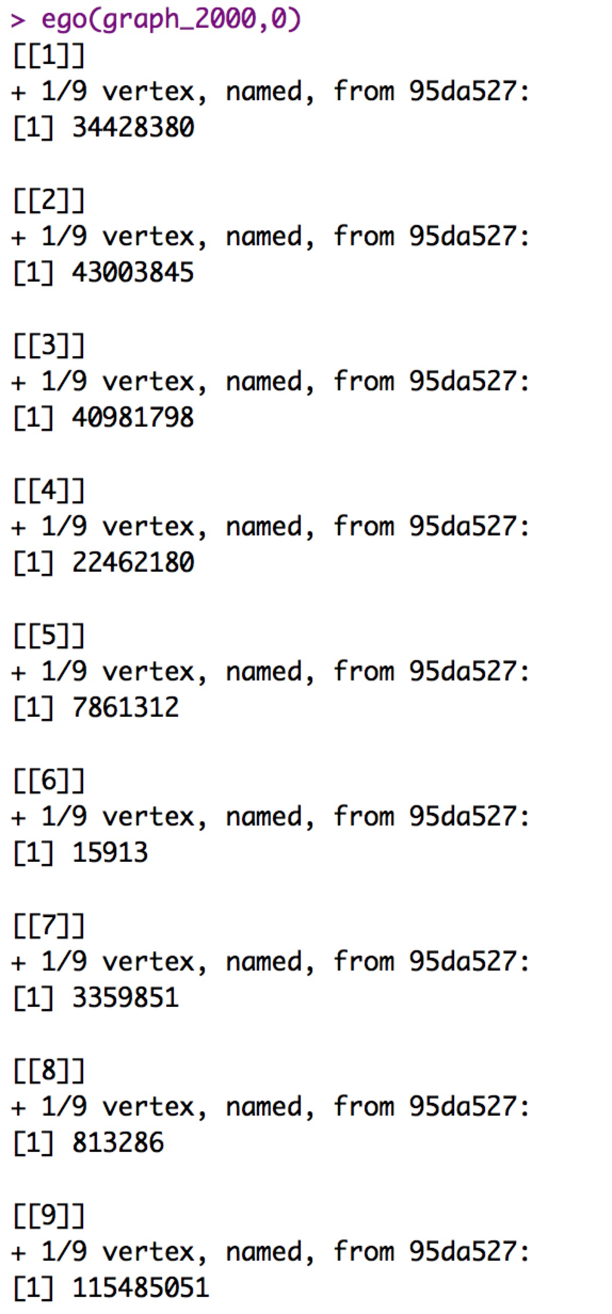

### (5) power centrality



